🔎 Question 1. Recap
We have:
- 1,000,000 records
- 1000 buckets (hash function distributes records into them)
- Block capacity = 100 records
- Constraint:
  - Each bucket must use its own blocks (no sharing).
  - Empty buckets don’t use blocks.
We want: minimum and maximum number of blocks needed.

✅ Step-by-Step Detailed Solution

1. Best Case (minimum blocks)
We minimize wasted space by filling blocks as fully as possible.
- 1,000,000 records ÷ 1000 buckets = 1000 records per bucket.
- For each bucket:
⌈1000/100⌉=10 blocks
- For 1000 buckets:
1000×10=10,000 blocks
👉 Minimum = 10,000 blocks.

2. Worst Case (maximum blocks)
We maximize wasted space by spreading records as unevenly as possible while still respecting the rules.
⚠️ Rule: each bucket must occupy at least 1 block if it has any records.
- Put 1 record in 999 buckets → each uses 1 block → 999 blocks.
- Remaining records:
1,000,000 - 999 = 999,001
- These go into the last bucket.
- Blocks required for that bucket:
⌈999,001/100⌉=9991 blocks
- Total blocks =
999 + 9991 = 10,990
👉 Maximum = 10,990 blocks.

3. Key Insight
- Minimization strategy: distribute records evenly across buckets so all blocks are full.
- Maximization strategy: distribute records unevenly so most buckets waste space with nearly empty blocks.

📘 Two More Similar Questions

Q2 (Variation with Empty Buckets Allowed):
Suppose we still have 1,000,000 records, but now the hash function distributes them into 2000 buckets instead of 1000. Everything else is the same: 100 records per block, each non-empty bucket must use its own block, and empty buckets do not consume blocks.
- What is the minimum and maximum number of blocks needed?

Q3 (Variation with Overflow Constraint):
We have 500,000 records and 500 buckets. Each block holds 50 records. As before, no two buckets can share a block.
- (a) What is the minimum number of blocks required?
- (b) What is the maximum number of blocks required if at most 10% of the buckets are allowed to be empty?

Solutions

Exercise 3.1
Prompt depends on Fig. 20 (not in the upload). Here’s how to do it:
- i. Insert g–j into buckets 0–3: Append to those buckets (respecting the scheme used in the figure: simple/linear/extensible).
- ii. Delete a, b: Remove entries; if using overflow chains, unlink nodes as needed; if using extensible or linear hashing, you typically do not immediately merge/shrink on deletions (see 3.2).
- iii. Insert k–n into buckets 0–3: Same as (i); watch for overflow and splitting depending on the scheme.
- iv. Delete c, d: Remove; consider lazy deletion markers if you need stable positions.
Without the original Fig. 20 bucket contents we can’t draw the exact final layout, but the step-by-step is: apply inserts/deletes in order, invoking the structure’s overflow handling (simple hashing → overflow chains; linear hashing → split pointer advance; extensible hashing → split on local depth, directory doubling when needed).

Exercise 3.2 – Deletions in Linear/Extensible Hashing
- Mechanics: Locate the record as usual.
- Method: Prefer lazy deletion (tombstone or flipping a “valid” bit). Periodically compaction/cleanup:
  - Linear hashing: don’t “unsplit” on every delete; consider occasional merges when load is well below the split threshold, or run rebalancing during maintenance windows.
  - Extensible hashing: allow bucket merges when a bucket and its buddy each have local depth d and their union fits into one block; if all buckets at global depth are merged away, you can halve the directory.
- Pros of restructuring (compression): space back, fewer cache misses, shorter chains.
- Cons: moving records/pointers is costly; can thrash if workload has bursts; may break external references unless an indirection (RID) layer is used.

Exercise 3.3 – Duplicates
Adjust algorithms to let a key map to multiple records.
- Simple hashing: store lists (or overflow chains) per key;
  - Insert: append to list.
  - Lookup: return the whole list.
  - Delete: remove one/all occurrences; chain maintenance needed.
  - Issue: long chains if skewed.
- Linear hashing: same as simple, but splitting redistributes all entries of that key suffix; duplicates may straddle primary/overflow blocks; keep duplicates together when possible to reduce probes.
- Extensible hashing: duplicates share the same bucket by the same key bits; on split, all duplicates follow the same child if the next bit is identical; large duplicate sets can trigger recursive splits (see 3.5).
Major challenges: longer probe lengths, bigger variance per bucket, and maintaining stable iteration order if required.

Exercise 3.4 – Hash h(i)= i mod B
(a) B = 10: Bad if keys are decimal-like (e.g., many values ending with certain digits). Values depend only on last decimal digit, so any pattern in that digit ⇒ severe skew.
(b) B = 16: Uses only the lowest 4 bits. Fine for uniform/sequential integers; bad for multiples of 16 (all map to bucket 0).
(c) Useful B’s: Choose B coprime to common key patterns; in practice use a prime (or power-of-two with a strong hash that mixes low bits).

Exercise 3.5 – Probability of Recursive Split (Extensible Hashing)
Let a block hold n records. On split (using the next hash bit), each record independently goes left/right with probability 1/2. A recursive split happens iff all n records go left or all go right:
P(recursive)=2⋅(1/2)^n+1
Examples: n=2⇒1/2^n

Exercise 3.6 – 4-bit hashes; block capacity = 3
We start with two empty buckets for prefixes 0 and 1.

(a) Extensible hashing; insert 0000, 0001, …, 1111
Final organization (after all 16 inserts): global depth = 3, directory of 8 entries; each bucket has 2 records that differ in the 4th bit:
- Bucket 000 → {0000, 1000}
- 001 → {0001, 1001}
- 010 → {0010, 1010}
- 011 → {0011, 1011}
- 100 → {0100, 1100}
- 101 → {0101, 1101}
- 110 → {0110, 1110}
- 111 → {0111, 1111}
All buckets ≤ capacity (3). (Order of arrival only affects when splits occur, not this final layout.)

(b) Linear hashing; threshold = 100%
With capacity 3 and 16 records, LH grows to 6 buckets. Two buckets end up with 4 records each, requiring overflow blocks:
- Buckets (by final indices 0..5):
  - 0: {0000,1000}
  - 1: {0001,1001}
  - 2: {0010,0110,1010,1110} ← 4 records (needs 1 overflow slot)
  - 3: {0011,0111,1011,1111} ← 4 records (needs 1 overflow slot)
  - 4: {0100,1100}
  - 5: {0101,1101}
Load factor = 16/(6⋅3)=88.9%≤100%. Overflows exist locally even though the global threshold is satisfied.

(c) Extensible hashing; insert in reverse 1111, 1110, …, 0000
Same final as (a): global depth 3, 8 buckets × 2 records (order only changes split timing).

(d) Linear hashing; threshold = 75%, reverse order
LH expands further to keep average load ≤ 75%. Final: 8 buckets, each holding 2 records; no overflows:
- Indices 0..7:
  - 0:{0000,1000}, 1:{0001,1001}, 2:{0010,1010}, 3:{0011,1011},
  - 4:{0100,1100}, 5:{0101,1101}, 6:{0110,1110}, 7:{0111,1111}.

Exercise 3.7 – External Pointers Prohibit Movement
Options to support external pointers:
- Indirection layer (stable RID): External pointers reference a record ID; a RID → current (bucket, block, slot) via a lookup table.
- Forwarding stub: Leave a tiny tombstone at the old address that forwards to the new location.
- Pinned anchor pages: Keep a fixed anchor (primary page) per key-range; overflow pages can move, but the anchor stays at a stable address.
- Logical handles: External refs use logical keys; a small index resolves to physical location (extra hop, most robust).
Trade-off: an extra indirection costs one more I/O but prevents dangling pointers during splits/merges.

Exercise 3.8 – Blocks vs. Load (Linear Hashing)
Let block capacity = k, threshold c, #buckets n, #records r = ckn.
(a) “Each key occurs exactly its expected number of times.”
Total blocks (including overflow) needed is simply the total records divided by block capacity:
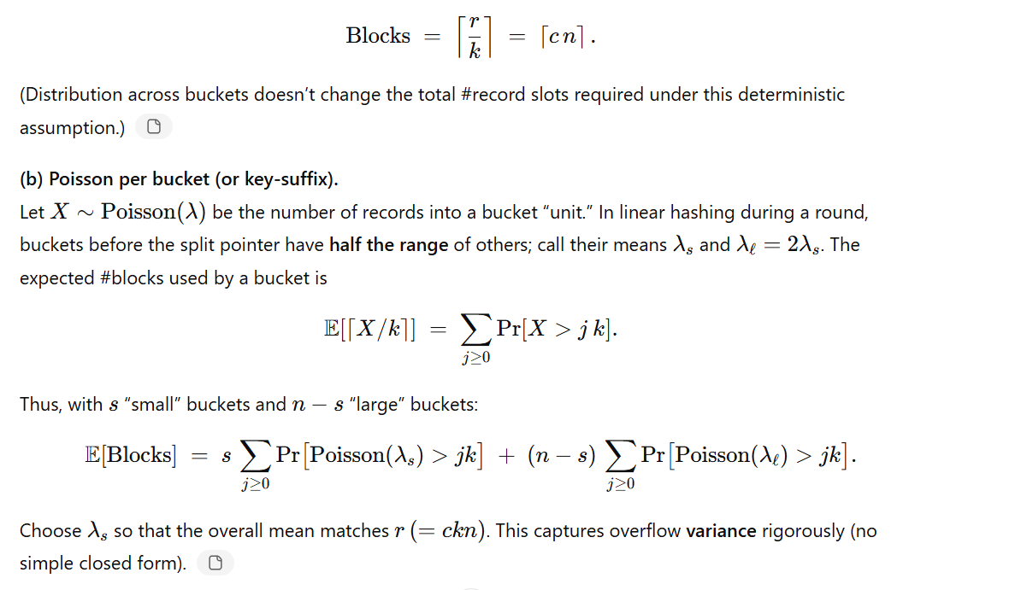

Exercise 3.9 – Min/Max Blocks (1,000,000 records; 1000 buckets; block = 100 rec; buckets cannot share a block)

